**192111610**

**A.Ravi**

**19. Install a C compiler in the virtual machine created using virtual box / VM Ware Workstation / Player and execute Simple C Programs.**

**VM with Installing C Compiler:**

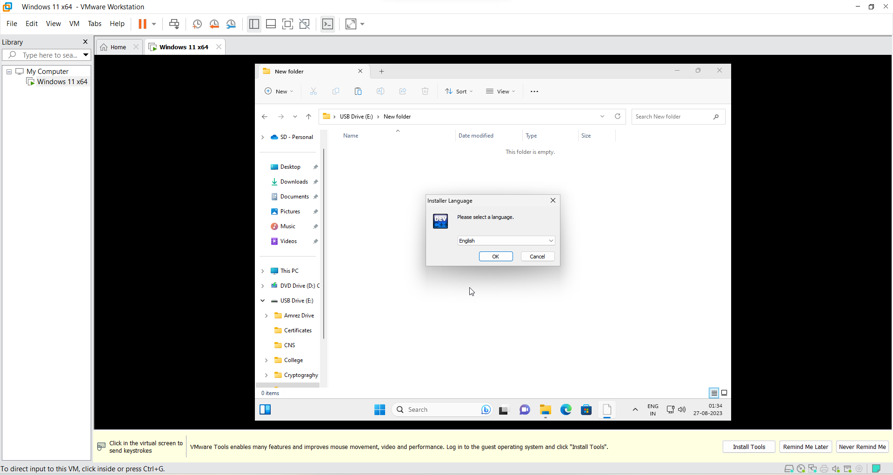

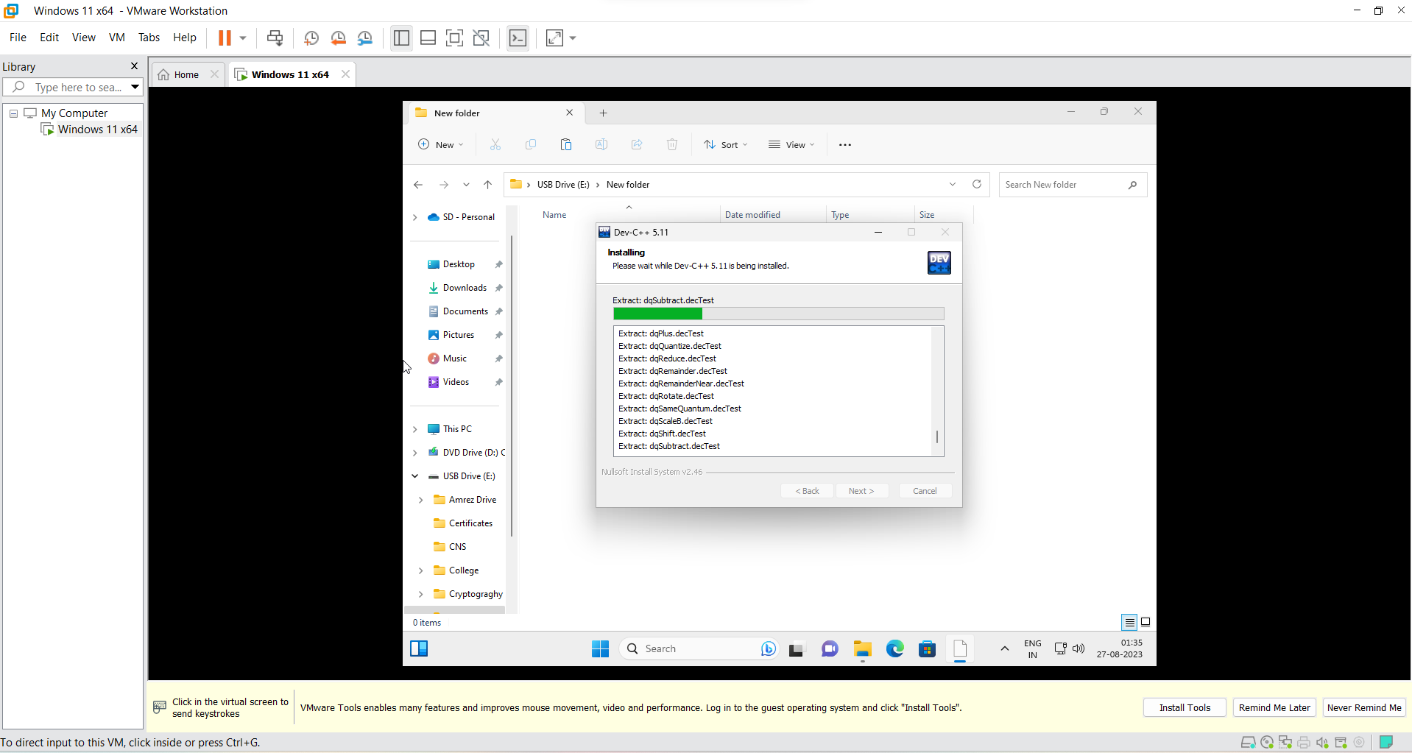

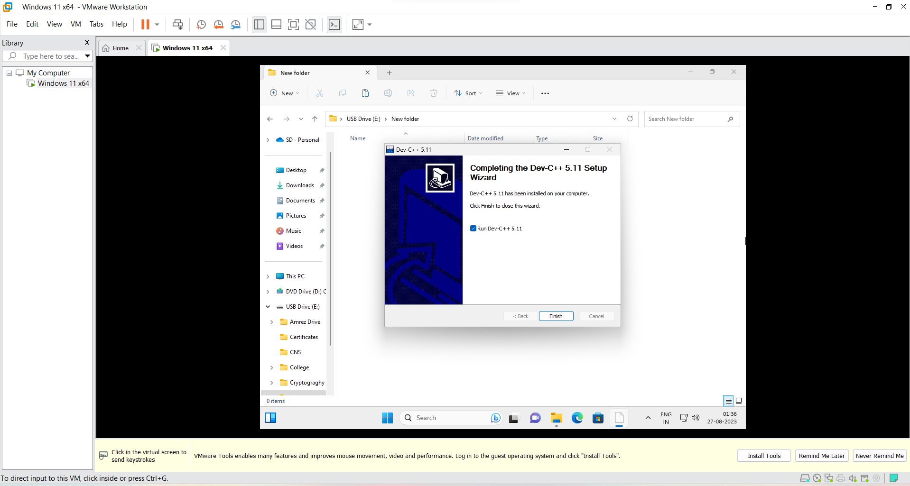

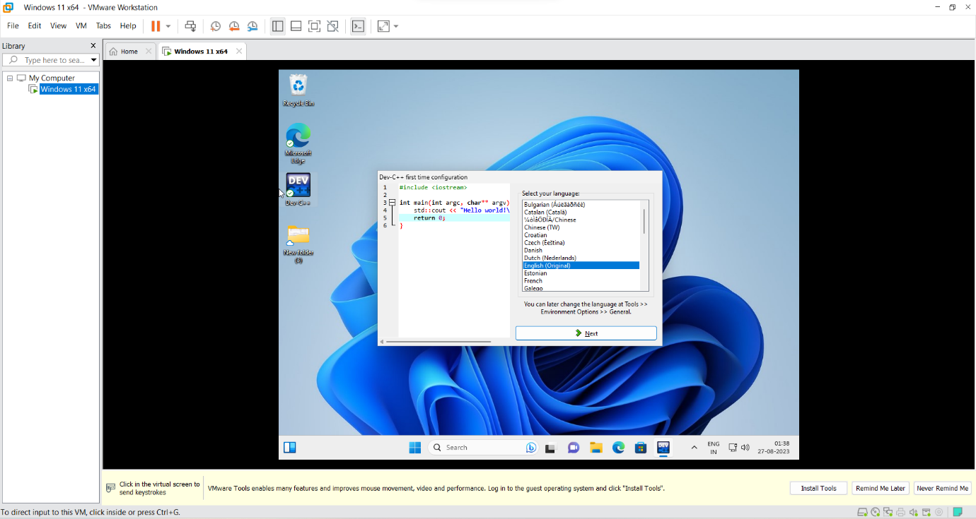

**VM with running Arithmetic operation using C programming:**

